Legend:
Electric components
Soldering
Organization
Safety notes
Mechanical/CAD

4/7/2026

Most components arrived, could not find header pins, so forced to plan out circuit board by putting available components down

Note that the step-down buck converters come in a connected pack of 5, so you’d have to break them into individual components yourself in order to solder them on

A trick is to solder the female header pins onto the perfboard and solder male header pins onto the electronic components (most already come with those), so you can switch out components whenever you need to (in case some of them break, etc) without having to re-solder anything. The buck converter seem to need to be soldered directly on though; could alternatively solder four male header pins and pair them with four corresponding female header pins (though this is hard to do in practice, since the header pins come in a row of ~20)

Please, before soldering, plan out your circuit on paper! This will help you see what need to be connected to what (in terms of pins) and whether you need to establish “lines” of solder that essentially serves as a giant piece of metal, which is useful for connecting, say, multiple components to the battery

4/8/2026

SOLDER THE WIRES NEXT TO THE DESIRED PIN when possible because this helps with reducing the amount of solder on one pin → less chance of two neighboring pins touching → less chance of a short circuit

It also might be a good idea, when soldering parts directly onto the board, to solder on the wire along with the components, i.e. put the wire through the perfboard hole and the hole of the part you’re trying to solder, bend the exposed metal part of the wire such that both are now attached/hinged about that one hole, solder it on, and then cut off the excess.
→ there is also the added benefit of having a “template” to connect two neighboring perfholes together

PLEASE make sure that the wires have a MINIMAL amount of exposed metal, as that could lead to short circuits later on (if two metal pieces touch when they’re not supposed to → short circuit)!

4/9/2026

Please check before soldering: LONG leg of capacitor = positive, SHORT leg of capacitor = negative! It is very important that you line those up with the power/ground for it to work. In other words, short leg connects to ground, long leg connects to power

Circuit board should be large enough to 1) house all the components and 2) leave at least 3-4 columns of empty holes in between the components. This leaves room for the wires on either side and some wiggle room; capacitors notably must be attached one column away from its neighboring components (simply because it’s big).

Metals get very hot very fast when heated. Use tweezers to hold things in place, or use tape. Avoid holding onto wires, etc. with your hands for too long.

Check the solder pen temperature before you start soldering components onto the board; if the solder is not turning runny almost immediately upon contact with the soldering pen, the temperature is too low! Too low a temperature will result in very jagged solder on the board and possibly impaired functionality (maybe even short circuits).

A trick to solder components onto the board (for things with pins that are hard to bend):
- Add a bit of solder to one of the holes that the electric component will touch. For instance, if there’s a four-pin header pin you want to attach, pick one of the four holes you’d like to have the pin headers “sit in.”
- Having the board upright (i.e., the side that all the electric components should be on), heat up the corresponding underside of the board so that the solder you just added is starting to melt.
- Push the component into the holes; one of the pins of the component should be going through the melted solder.
- Take the soldering pen away from the board. The solder should solidify and the component is now held in place.
- Flip the board over (underside, where all the soldering should be done) and proceed normally.

This diagram might be helpful:
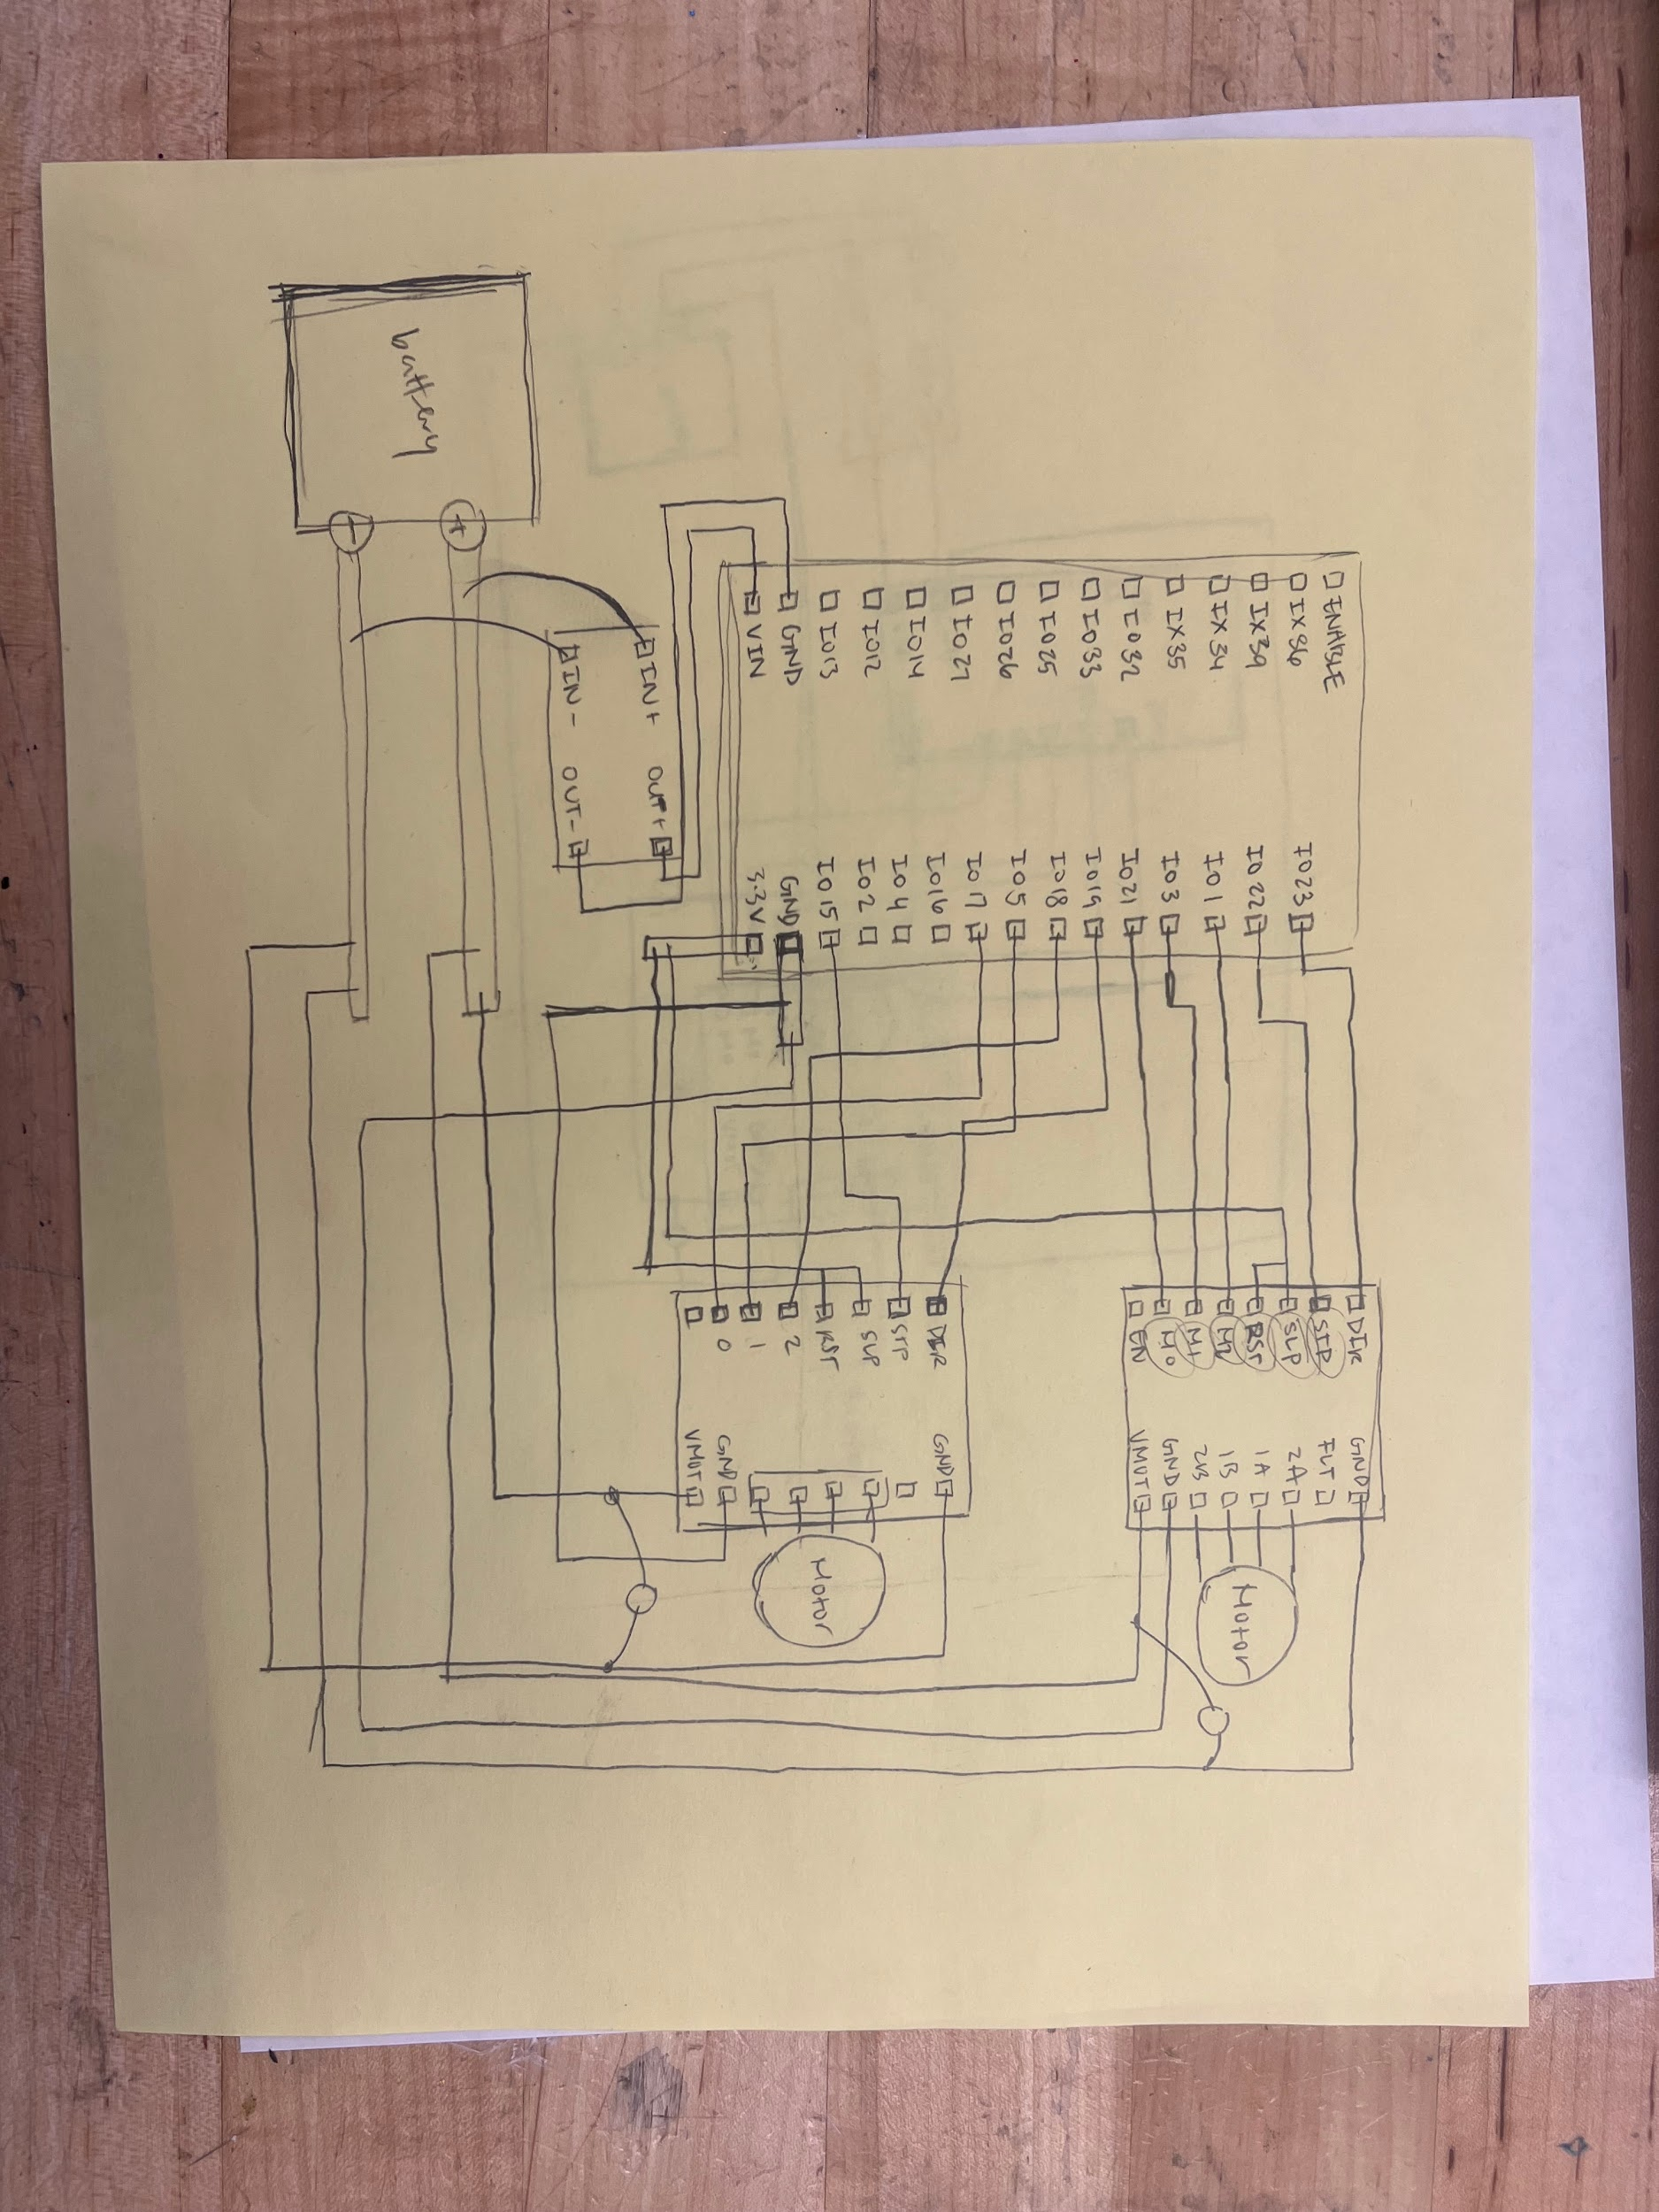

4/22/2026

Might be a good idea to color code your wires! For instance, use red for power, black for ground, and then, as an example, blue for the DIR pin and yellow for the M0-M2 pins.

Please measure everything first before committing with a 3D print! I personally did not do this my first time CADing and then I ended up with printed parts that were just way too small for my electric components. Sometimes the values given on, say, Amazon are a bit too small and so if you go directly with that without measuring yourself, you could be very off.

Another trick to solder components (particularly wires, etc that are very flexible):
- Have the wire (exposed parts, or as I like to call it, the “feet” of the wire) go through the holes you want to solder. You can leave them pretty long, as you will be able to clip them once you’re done.
- Bend the tips of the wires so that the wire is locked in place and won’t fall out when you flip the board over to expose the underside/side you want to add solder to
- Solder as normally!
- Clip the excess metal after you’re done.

Also a good idea to prototype with cardboard before you commit to printing

4/23/2026

When there is a 3D print design you have in mind, look on websites like Thingverse first to see if people have already created similar models. If they do exist, this will save you a ton of time (especially considering you could just remodel certain parts to better fit your need); if they are similar but not too relevant to your project, you at least get a sense of what other people’s designs look like, which may give you good inspiration for your own designs.

At the end of every work session, write some short bullet points on what you achieved that day, any setbacks you experienced, and any difficulties or problems (and whether those have been resolved). I think this will give you a nice record of the outstanding work and what’s been completed, which could come in handy when you take a break from working on the project and want to come back to it a few days later. This will also help you communicate with others (experts) who might be able to help you in a specific issue, since it’s important you can explain yourself clearly.

5/12/2026

Before you solder anything…check GPIX vs GPIO pins and know where they are. Some pins are input only (GPIX) and thus are not good for motor drivers.

Check if any of the components need to have heat sinks added to them! This will help ensure that the components work correctly and last for a longer time, since it is very common that electric components get “fried” if they get too hot. There is a special adhesive you’ll need to use, so be sure to check those out too.

